Autumn term plan
Suggested activities for your club

This term your challenge is to Go Green!

This November world leaders are meeting in Glasgow to make big decisions about the planet. These decisions will shape the future of our world, and the futures of millions of people around the world.

We need your club to speak out and Go Green to support our global family!

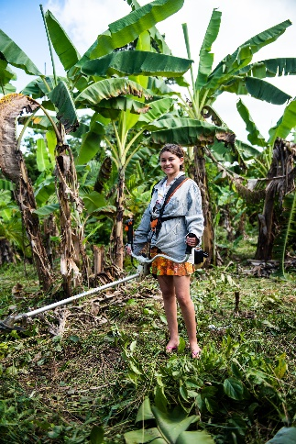
Find out about the Amazon
Did you know that the Amazon stretches over nine countries in South America? Did you know it has the widest river in the world? And did you know that the Amazon is so important to the earth's climate and to all of us? Watch our national assembly together on 16 September to get clued up about the Amazon rainforest and how we all have to play our part to protect it.
https://cafod.org.uk/News/Events/National-assemblies

Go Green for CAFOD
This term join schools all over England and Wales in going green! Whether it’s a vibrant green clothes day, a pea green soup lunch, or a bright green bake sale, however you raise money, make it bright green. Pick a day for your fundraiser, make posters to display in your school, and use the CAFOD Go Green film about Luana in the Amazon to tell others why going green is so important.
https://cafod.org.uk/Education/Primary-teaching-resources/Harvest-resources-children

Lead collective worship
Pope Francis says “Climate change affects us all, but it’s the poorest communities who suffer the most.” Use our Laudato Si PowerPoint and script to lead a collective worship with your class on caring for the earth.
https://cafod.org.uk/Education/Primary-teaching-resources/Collective-worship- primary/Laudato-Si-collective-worship

Take the Eyes of the world action
Use our Eyes of the world template, or get creative and use pens, pencils, paint or photography to design pairs of eyes to show the government that we are watching them this November, and that we want them to make good decisions to help all members of our global family.
https://cafod.org.uk/Education/Primary-teaching-resources/Eyes-of-the-world
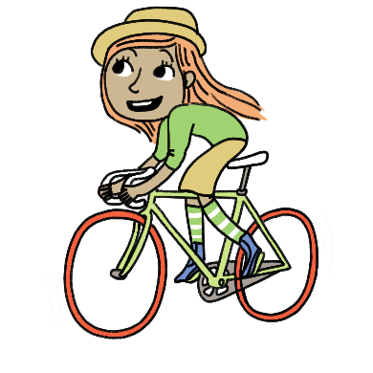
Set up eco actions
How green is your school? As a club, think about what else your school could do to look after the planet. How much recycling do you do? Could you cut down on plastic? Do you turn lights and ICT equipment off or close doors to conserve heat? Why not organise a week of walking or cycling to school?

Meet the changemakers of Peru
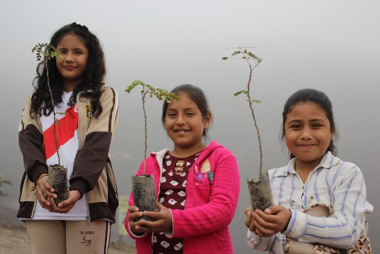
Find out how young people in Peru are taking care of their environment and making a big change in their communities.
You can order free changemakers postes, and use an app to watch them come to life. Think about how you could display these in your school for others to see.
https://cafod.org.uk/Education/Primary-teaching-resources/Changemakers-in-Peru

